**Creation Of Initial Reserve**

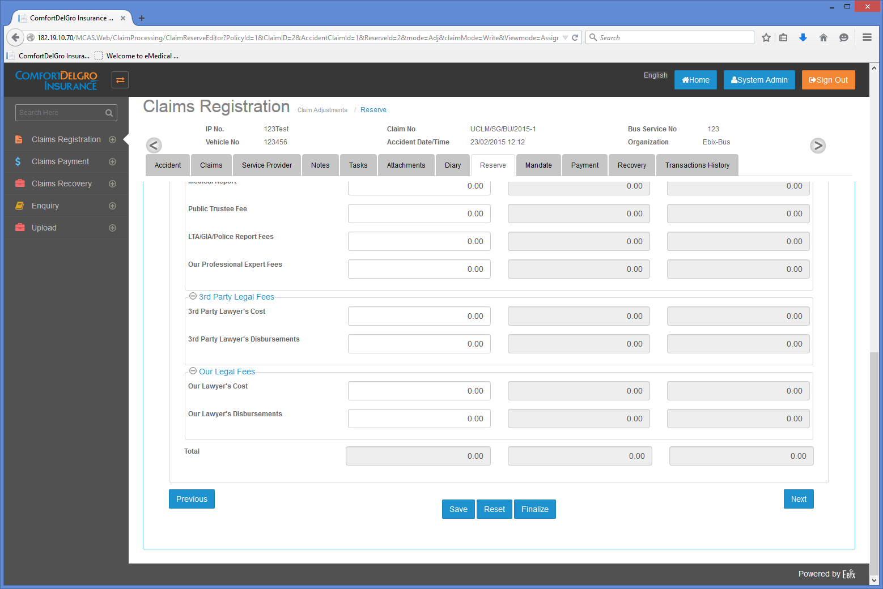

**Requirements:**

1. Need to remove the Finalize Button
2. For creating of reserve in the Outstanding Reserve (common understanding as Initial Reserve), user will enter the amount first. After clicking save, fields that have values in the Outstanding Reserve will not be editable.
3. Fields that has no values can still be editable when user re-selects the Claim. As long as there are new values in any of the fields in the Outstanding Column, it will not be editable upon clicking on the SAVE Button.
4. System to show message when SAVE button is clicked when there’s new value – “Please Note That Fields In The Outstanding Reserve Will Not Be Editable Once It Is Saved.” and have two buttons “Yes” & “Cancel”. If yes is clicked, show message “Records are saved successfully”.
5. Reserve Movement will be open for editing for fields in Outstanding Reserve that has values.
6. User can enter + and – value in the Reserve Movement Field. –value means Current Reserve will be reduced by that amount.